**Architecture for shiphub printer(infra part)**

Training video: https://drive.google.com/open?id=1KSjmavo9Atg8HYwJYTgj4F1OPt-6LM8J

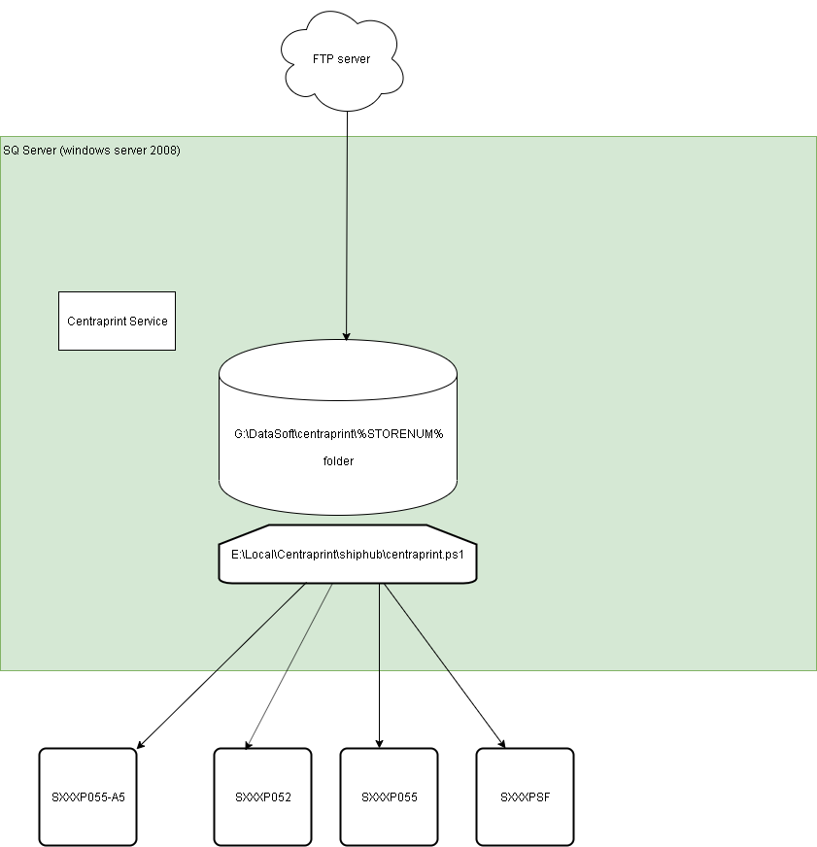

**Important files and folders:**

*G:\DataSoft\centraprint\%storenum%*

This folder is for png , pdf file download fromFTP server.

*F:\Local\centraprint*

This folder is for centraprint log

*E:\Local\Centraprint*

This folder is for centraprint configuration and exe file.

*E:\Local\Centraprint\centraprint.exe*

This is exe file for centraprint

*E:\Local\Centraprint\settings.xml*

This is configuration file for centraprint. It contains FTP server url , user and password used for access FTP server , printer information , log path , download path , command line needed to be run etc.

*E:\Local\Centraprint\centraprint_install.bat*

Centraprint service Install script

*E:\Local\Centraprint\centraprint_uninstall.bat*

Centraprint service unInstall script

*E:\Local\Centraprint\shiphub*

Script folder for shiphub printer

*C:\Sources\CentraPrint*

Centraprinter source when server installed

**Important service and process**

Centraprint service

Centraprint.exe

**Working flow :**

1. Centraprint service gets the PNG or PDF files from FTP server which is set in configure file. Download to G:\DataSoft\centraprint\%storenum%
2. Centraprint service check the state of printer configured , if printer is not ok , the working flow will be stopped.
3. Centraprint service run commands which is set in configure file , for shiphub store, there will be 3 different cases , for pdf and png files , will run E:\Local\Centraprint\shiphub\centraprint.ps1 which will sent A5 shopping list for A5 printer and price tag for P055 printer. For d4et file , it will run rundll32.exe url.dll command and send to P052 printer. For png file , it will run E:\Local\Centraprint\shiphub\centraprint.ps1 which will be sent PNG file to PSF printer to print .

**Printer configuration part :**

There will be 2 printer entrance added at SQ server for shiphub store SXXXP055-A5 and SXXXPSF :

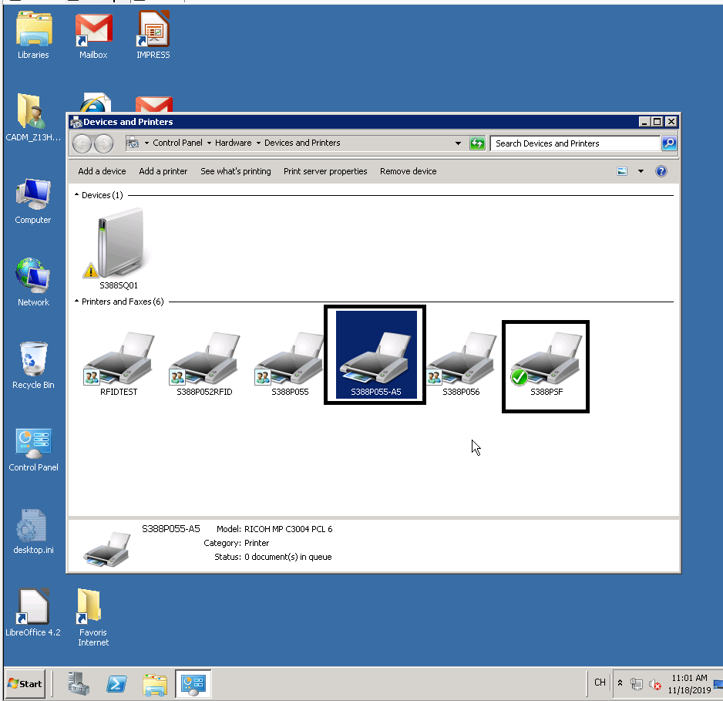

SXXXP055-A5

Normally, it is the P055 printer for store but not all stores use P055. you can check printer properties to confirm.

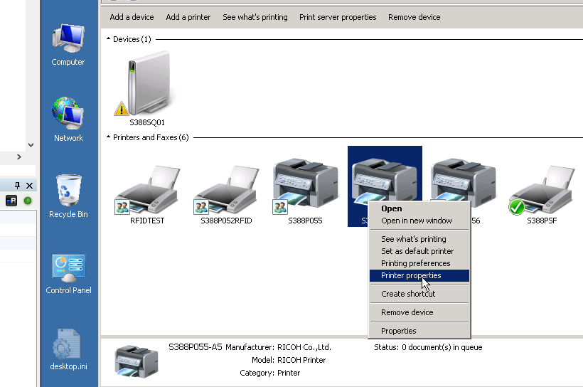

And P055-A5 is for print A5 shopping list , the special configure is it can only print A5 size paper and input tray is bypass tray, normally the configuration for this printer is no need to change after deploy so level1 and level2 have no rights to change this part.

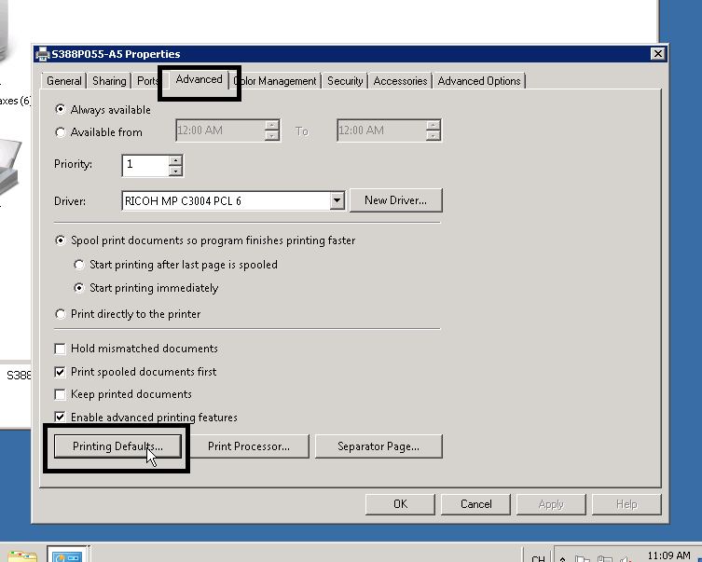

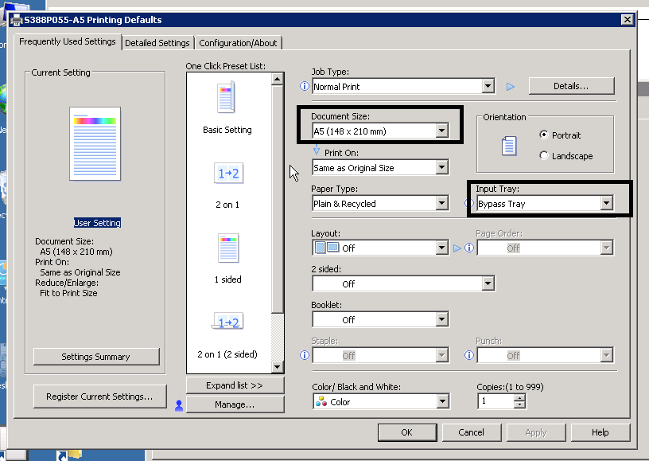

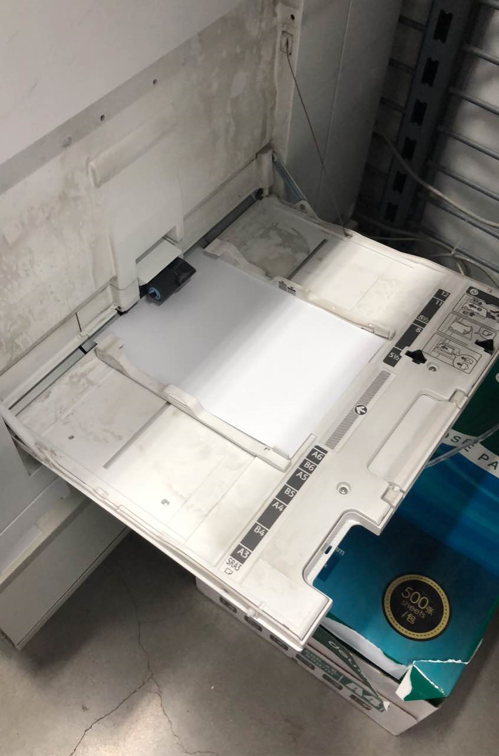

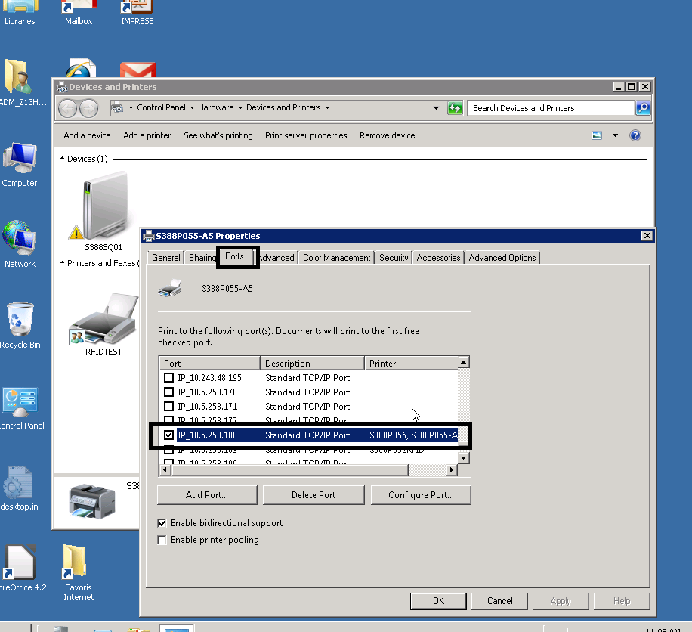

And this printer has web interface for manage . You can access web to check the status for printer.

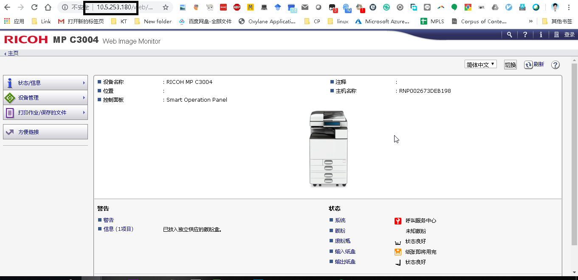

SXXXPSF

This printer is for express order like this one:

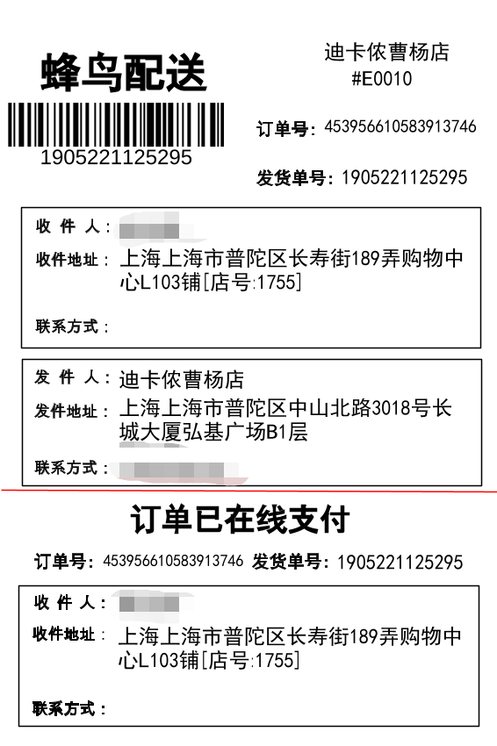

The model for this printer is GK888t . The special setting for it :

Ip is static. 10.XXX.XXX. 178

Paper is set to 100mm * 150 mm

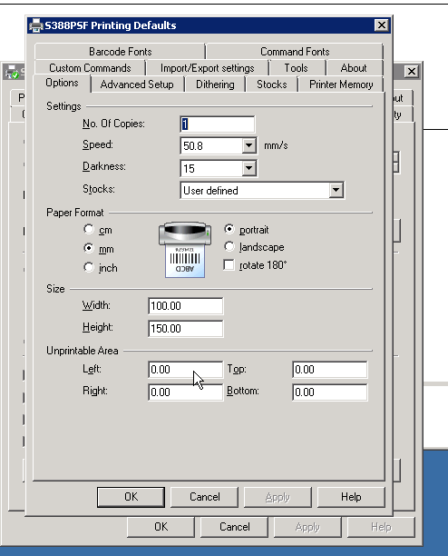

Media type sets to thermal direct

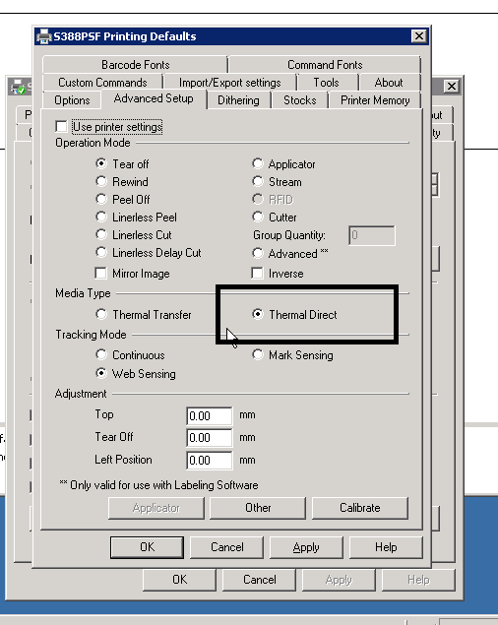

Here’s product description for Zebra .

English version:

https://drive.google.com/file/d/1reIj1ks_ls9BDPXon1jGDD79eg3Dpglr/view?usp=sharing

Chinese version: [gk888t-ug-zhcn.pdf](https://drive.google.com/file/d/1UmC2urEDUVHsaLq5MC7oP1j2y3oA6QML/view?usp=sharing)

There is one LED light on printer for status. You must keep green light , blinking light or green light are abnormal.

Press and hold Feed button for server seconds , and green status LED will flash a number of times in sequence , one flash will print configuration status label which can be used to verify the network configuration .

And two flash will start one standard auto media calibration .

For detail you can check at product description manual page 87 for detail.

Common issue :

1 . The status light is green and keep flash

Normally , for this issue , user just need to press the LED once and the flash will stop

2. The printer stuck after one print and LED turns to RED.

Normally it is due to the media calibration , let user restart printer and do the standard auto media calibration . Then the printer should come to normal.

3. P055 is offline

This may due to the network connection or hardware issue.

For network connection， you should ping the printer first, if can’t ping , pls follow normal network connection issue process to deal with (Let user confirm connection is ok , change the network port to confirm whether it is printer network adapter issue or network interface module)

If you can ping P055 but P055 still shows offline.You can access the web interface and check whether the printer status is ok .

The ok status should as blow:

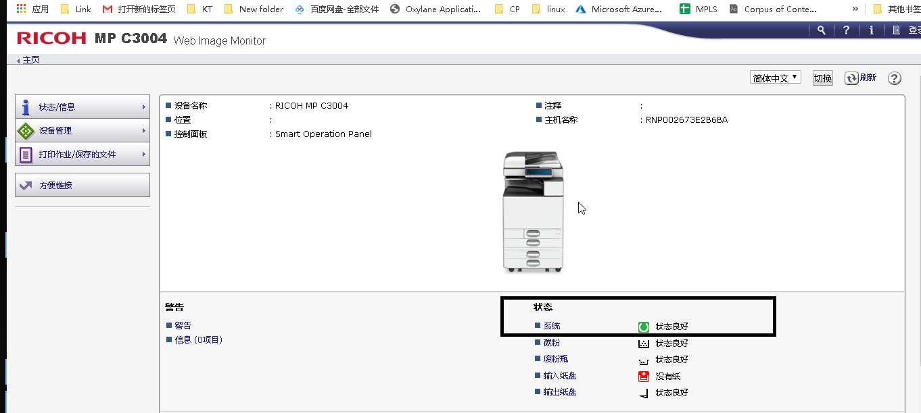

The error status example :

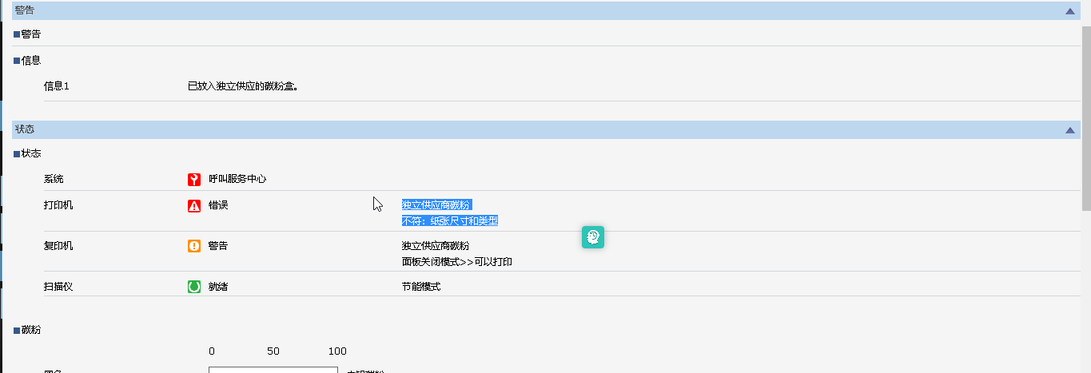

Error:

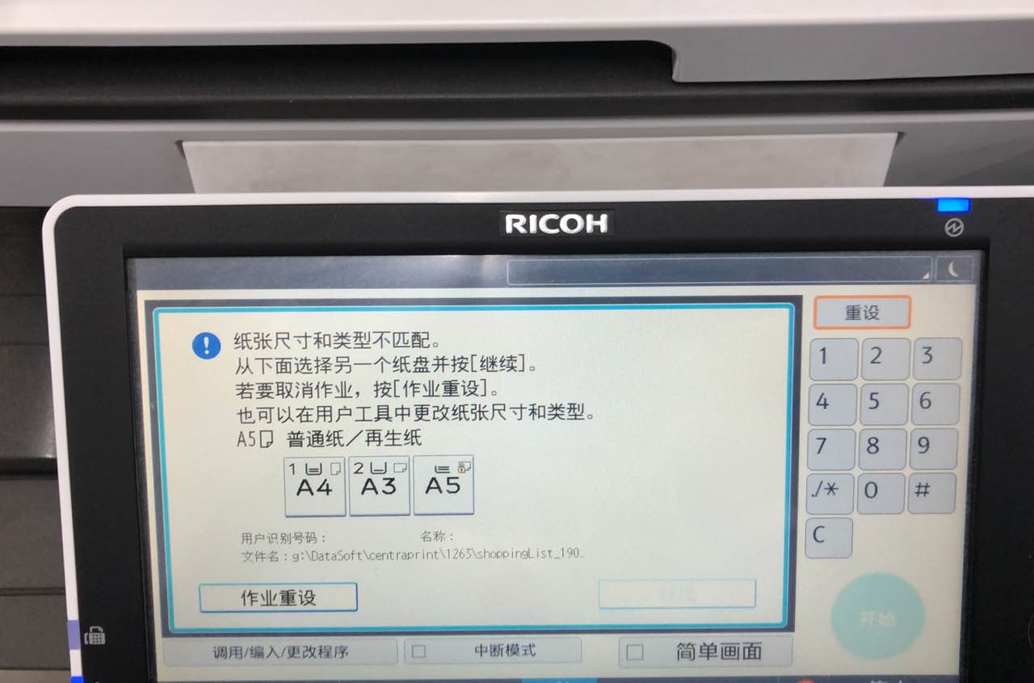

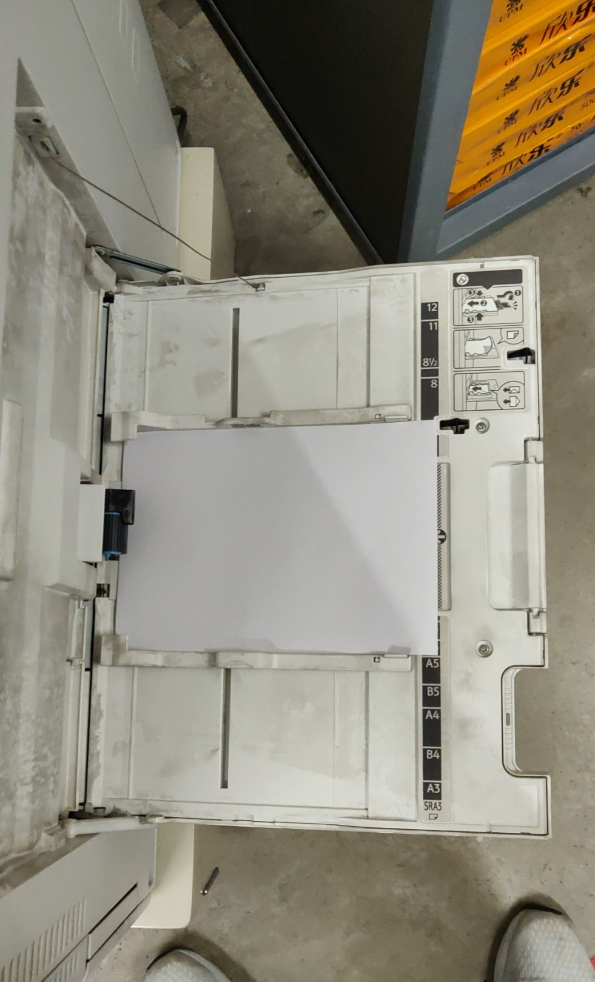

Reprint shopping list : [[shiphub][decapac]如何重打shopping list](https://docs.google.com/document/d/1T9HEtBxN_XcU8OeNKWuAup7sUTvS1tMNJCJM10Mm_hc/edit)

Reprint delivery label :

[[shiphub][decapac]如何重打delivery label](https://docs.google.com/document/d/1cm0135gnCjspzmp5Vm3YtAjCWlC4K_1_dcJdobhK0ZI/edit)

Store information:

[C&C 2h Country rollout Plan & Info](https://docs.google.com/spreadsheets/d/1aUe5fwcszHx1N9z-M2gm-WrmG4L89ZS-HAp7wGKcoss/edit#gid=1967738287)

PSF print mass code:

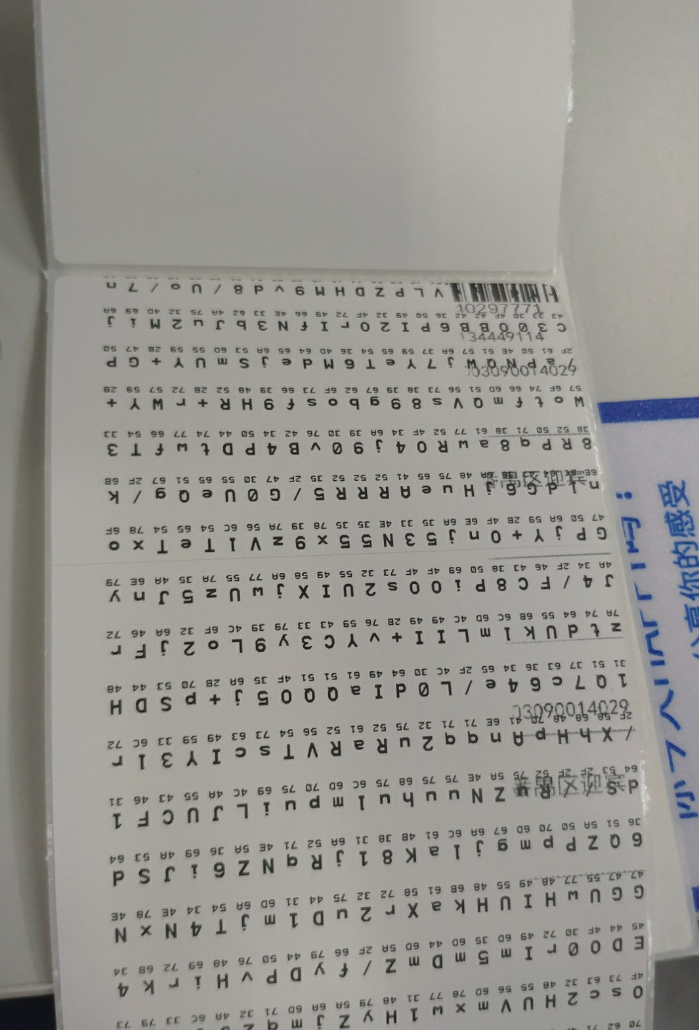

This is due to the exe in E:\Local\Centraprint\shiphub not correct copied.

You can copy from : \\chlbfi02\g$\chj\gk888t\ZD5-1-16-7110\shiphub

The printed not in correct position. You can try do the calibration reference follow video

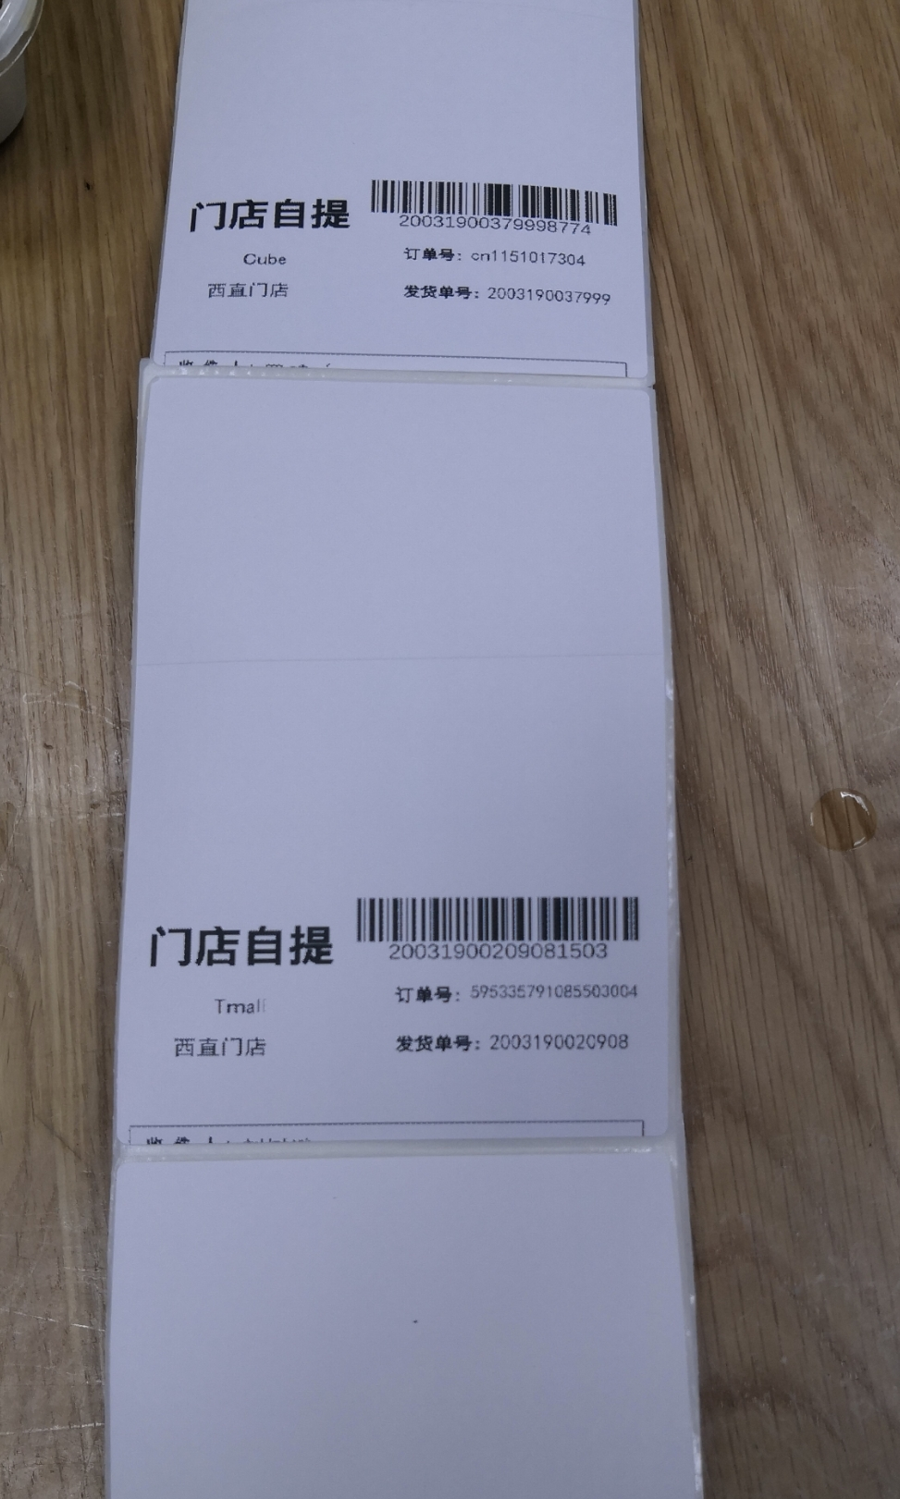

https://drive.google.com/open?id=1PNt8Aeood1QlwQGFvFhdavk3O0nZJCW7

FTP服务器接收文件文件名标准:

A4:

shoppingList_XXXX.pdf

热敏:

eleme_xxxx.png

tmalldss_xxxx.png

sfsamecity_xxxx.png

sf_xxxx.png

samestore_xxxx.png